|  |  |
| --- | --- |
| **EX.NO: 01** | **OPERATOR, INPUT AND OUTPUT OPERATIONS** |
| **DATE:** |

**PROGRAM 1:**

Write a program to calculate the area of a triangle using Heron’s formula.  
(Hint: Heron’s formula is given as: area = sqrt(S*(S–a)*(S–b)*(S–c)))

import math

a=int(input("Enter a number(a):"))

b=int(input("Enter a number(b):"))

c=int(input("Enter a number(c):"))

s=(a+b+c)/2

area=math.sqrt((s*(s-a)*(s-b)*(s-c)))

print("Area of triangle is:",area)

**OUTPUT:**

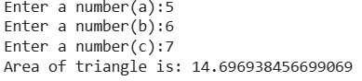

**PROGRAM 2:**

2.Write a program to calculate the distance between two points.

import math

x1=int(input("Enter a point(x1):"))

y1=int(input("Enter a point(y1):"))

x2=int(input("Enter a point(x2):"))

y2=int(input("Enter a point(y2):"))

d=math.sqrt(((x2-x1)**2)+((y1-y2)**2))

print("The distance between two points:",d)

**OUTPUT:**

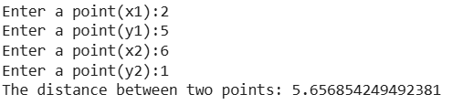

**PROGRAM 3:**

3.Write a program to calculate the area of a circle, rectangle, triangle, and square.

import math

print("Area of circle")

r=int(input("Enter a radius:"))

area=math.pi*r*r

print("Area of circle is:",area)

print("Area of rectangle")

l=int(input("Enter a length:"))

b=int(input("Enter a breadth:"))

area=l*b

print("Area of rectangle is:",area)

print("Area of triangle")

b=int(input("Enter the base:"))

h=int(input("Enter the height:"))

area=0.5*b*h

print("Area of triangle is:",area)

print("Area of square")

s=int(input("Enter a side:"))

area=s*s

print("Area of square is:",area)

**OUTPUT:**

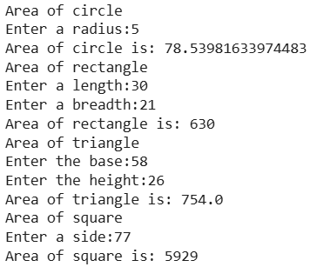

**PROGRAM 4:**

4.Write a program to print the digit at one’s place of a number.

n=int(input("Enter the number:"))

one_n=n%10

print("The one's digit of the number is:",one_n)

**OUTPUT:**



**PROGRAM 5:**

5.Write a program to calculate the total amount of money in the piggy bank, given the coins of ₹10, ₹5, ₹2, and ₹1.

a=int(input("Enter the number of ₹10 coins:"))

b=int(input("Enter the number of ₹5 coins:"))

c=int(input("Enter the number of ₹2 coins:"))

total_amt=a*10+b*5+c*2

print("The total amount in the piggy bank is:",total_amt)

**OUTPUT:**

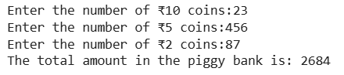

**PROGRAM 6:**

6.Write a program to calculate the bill amount for an item given its quantity sold, value, discount, and tax.

q=int(input("Enter the quantity of the item:"))

v=int(input("Enter the value:"))

d=int(input("Enter the discount in %:"))

d=d/100

t=int(input("Enter the tax in %:"))

t=t%100

bill_amt=q*v-d+t

print("The bill amount is:",bill_amt)

**OUTPUT:**

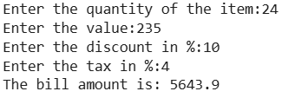

**PROGRAM 7:**

7.Write a python program to calculate a household's electricity bill.  
The user should enter the number of units consumed. The charges are as follows:

* For the first 100 units: ₹1.50 per unit
* For the next 100 units (101–200): ₹2.00 per unit
* For units above 200: ₹3.00 per unit

A fixed meter charge of ₹50 is added to the bill.  
Display the total amount to be paid with a proper bill format

n=int(input("Enter the number of units consumed:"))

print("Number of units consumed:",n)

if(n<=100):

print("bill:",1.50*n+50)

elif(n>100 and n<=200):

print("bill:",2.00*n+50)

else:

print("bill:",3.00*n+50)

**OUTPUT:**

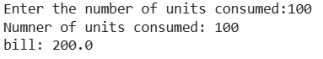

**PROGRAM 8:**

8.Develop a Python program that calculates an employee’s net salary. Accept input for:

Employee name and ID

Number of hours worked

Hourly wage

Calculate the gross salary and deduct 10% as tax. Display a proper salary slip with all details.

e_name=input("Enter your name:")

e_id=int(input("Enter your ID:"))

e_hrs=float(input("Enter the hrs worked"))

e_wages=float(input("Enter the hourly wages:"))

grs=e_hrs*e_wages

tax=0.10*grs

grs_n=grs-tax

net_salary=grs_n

print("\n-------- Salary Slip --------")

print(f"Employee Name: {e_name}")

print(f"Employee ID: {e_id}")

print(f"Hours Worked: {e_hrs}")

print(f"Hourly Wage: ₹{e_wages}")

print(f"Gross Salary: ₹{grs:.2f}")

print(f"Tax Deduction (10%): ₹{tax:.2f}")

print(f"Net Salary: ₹{net_salary:.2f}")

print("-----------------------------")

**OUTPUT:**

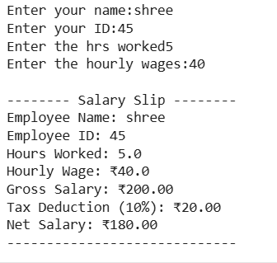

**PROGRAM 9:**

9.Write a Python program to calculate the total cost of movie tickets. Accept:

Number of tickets

Ticket category (Silver: ₹120, Gold: ₹180, Platinum: ₹250)

Add 18% GST to the ticket cost. Display a formatted bill.

n=int(input("Enter the no.of tickets:"))

a=input("Enter the class:")

print("The bill")

if(a=="silver"):

print("Total cost",120*n+18/100)

elif(a=="gold"):

print("Total cost",180*n+18/100)

else:

print("Total cost",250*n+18/100)

print("class",a)

print("no.of tickets:",n)

**OUTPUT:**

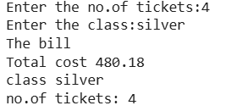

**PROGRAM 10:**

1. Develop a Python program that estimates travel fare based on distance and transport mode.

**Input:**

Distance (in km)

Mode (Bus: ₹5/km, Train: ₹2/km, Cab: ₹10/km)

Calculate and display the total fare and estimated travel time (assuming constant speeds for each mode).

d=int(input("Enter the distance:"))

m=input("Enter the mode:")

if(m=="bus"):

print("Total fare:",5*d)

print("travel time:",d/5)

elif(m=="train"):

print("Total fare:",2*d)

print("travel time:",d/2)

else:

print("Total fare:",10*d)

print("travel time:",d/2)

**OUTPUT:**

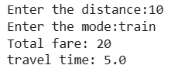

|  |  |  |
| --- | --- | --- |
| **DEPARTMENT OF CSE** | | |
| Program | 10 |  |
| Output | 5 |  |
| Viva-Voce | 5 |  |
| Total | 20 |  |